Experiment No: 1
Aim:
To design an Entity Relationship (ER) diagram for the College database and convert the ER diagram into relational tables.
Description:
The system consists of entities such as Student, Class, Semester, Subject, and Marks. A student attends a class, enrolls in subjects, and scores marks in each subject. Each class belongs to a specific semester, and a semester can have multiple classes. The marks entity stores internal and final assessment details of students. This ER diagram helps clearly define relationships between entities and avoids data redundancy. It provides a strong foundation for designing a relational database for managing student academic records.
Entities and Attributes
- STUDENT
Represents student studying in the institution.
Attributes:
  - USN (Primary Key)
  - SName Address
  - Phone
- CLASS
Represents a class allotted to students.
Attributes:
  - USN
  - SSID (Section / Class ID)
- SEMESTER
Represents the academic semester.
Attributes:
  - SSN
  - Sem
  - Sec
- SUBJECT
Represents subjects taught in the course. Attributes:
  - Subcode (Primary Key)
  - Title
  - Credits
  - Sem
- MARKS
Represents the marks scored by students.
Attributes:

  - USN
  - SSD
  - Test1
  - Test2
  - Final
  - SCode
Relationships:

1. STUDENT – CLASS Relationship: Attends
- A student attends a class.
- A class can have many students.
2. CLASS – SEMESTER
Relationship: Belongs To
- A class is for one semester.
- A semester can have multiple classes.
  - STUDENT – SUBJECTRelationship: Enrolls • A student can enroll in many subjects.
- A subject can have many students.
  - STUDENT – MARKSRelationship: Scored
- A student scores marks in different subjects.
- Marks depend on the student and subject.

ER diagram:
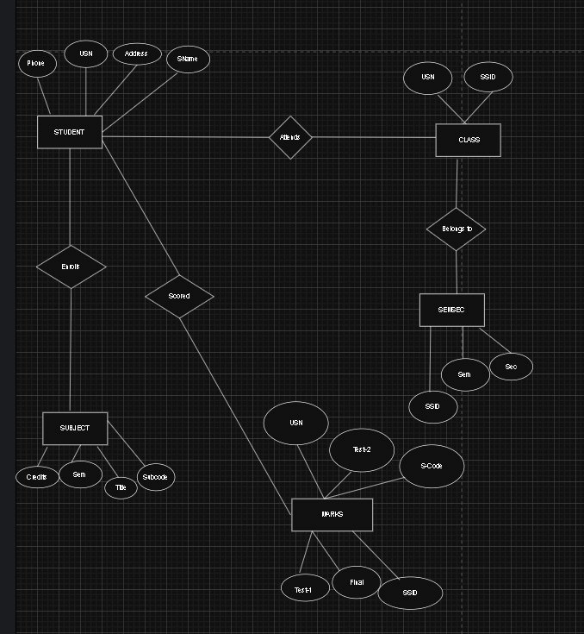
Conclusion: This ER diagram shows the relationships between students, classes, semesters, subjects, and marks, helping to design an efficient academic database.

